Ideation Phase
Define the Problem Statements

Date | 5 April 2026
Team ID | SWTID-2026-8642
Project Name | Streamlining Ticket Assignment for Efficient Support Operations
Maximum Marks | 2 Marks

Customer Problem Statement:
Create a problem statement to understand the challenges faced in support ticket management. This template helps focus on improving ticket assignment efficiency and delivering better support experiences.
A well-defined problem statement allows the team to identify gaps in the current ticket assignment process and develop an effective automated solution. It also helps in understanding both support agents’ and customers’ perspective
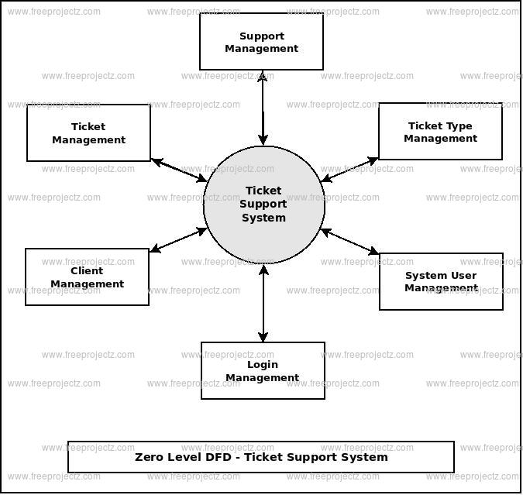
Example:
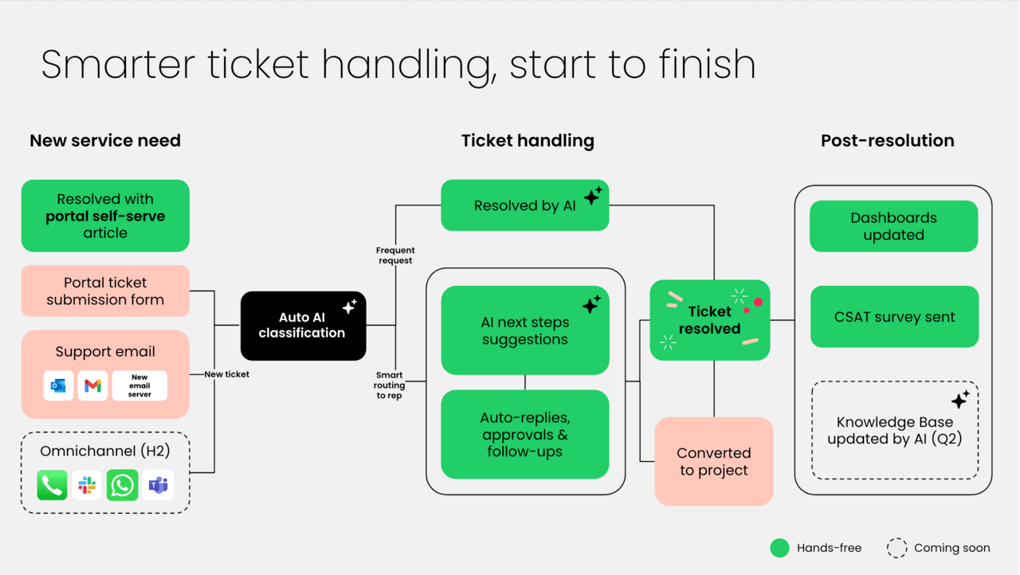
Problem Statement (PS) | I am (Customer) | I’m trying to | But | Because | Which makes me feel
PS-1
PS-2

